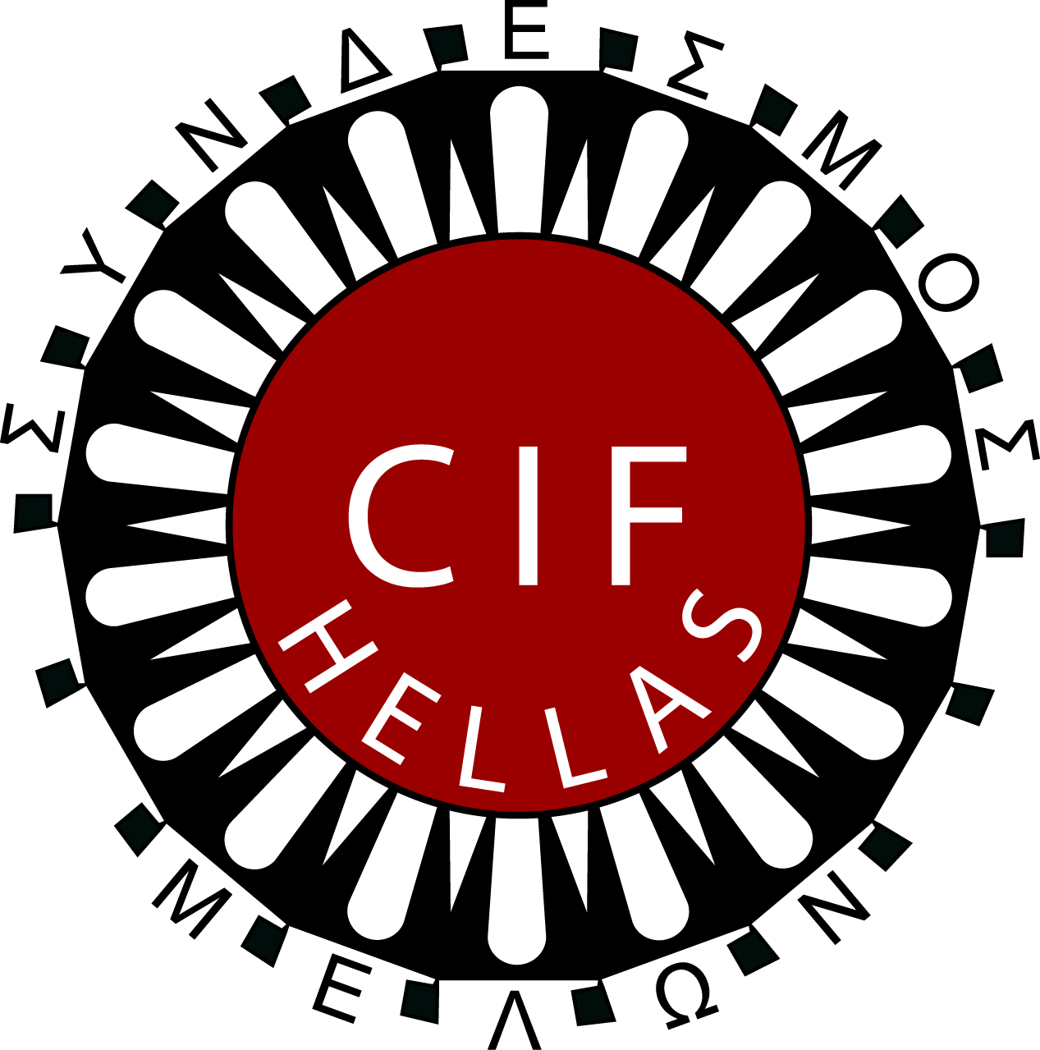
INTERNATIONAL PROFESSIONAL
EXCHANGE PROGRAM 2023
Athens 13-27 May 2023

Professionals working in the field of Social Work/Human Services are invited to apply for CIF- Hellas International Professional Exchange Program 2023.

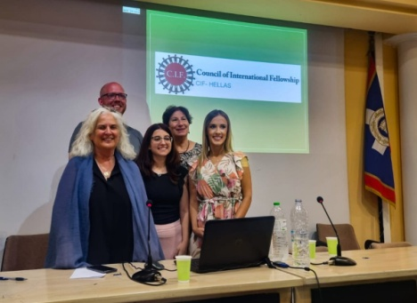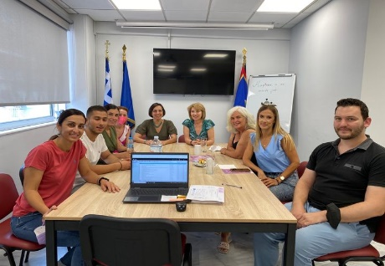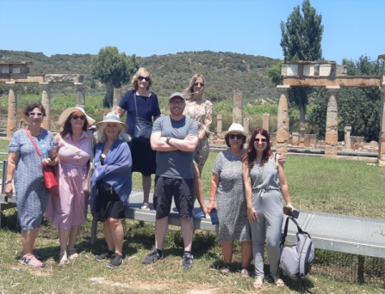

The program includes:

-Orientation:
Seminar and lectures to familiarize participants with the socio/economic situation in Greece. Including also visits to places of cultural interest.
-Agency visits and Placements: Participants will visit social organizations and agencies related to their own specialized field, to observe and experience professional social work in Greece.
-Experience in a multicultural group:
Participants will exchange experiences about their work

-Evaluation and Farewell event:
The last two days participants will share gained knowledge and experience and will receive their certificates.
-Host Family Living: Living with host families provides participants with a unique cultural experience and develops lasting cross-cultural friendships.
- Language: English
- Number of participants: Five (5)The program will take place only if more than three(3) successful applicants are able to participate.

The Financial terms: 400 euro as a contribution to program costs.
The participants are responsible for their international travel and medical insurance. Internal transportation and half board expenses are covered by the program.
Deadline for applications is 30/01/2023 through the national branch, contact persons or directly to CIF Hellas, cifhellas@cifhellas.gr

More information: www.cifhellas.gr and www.cifinternational.com

