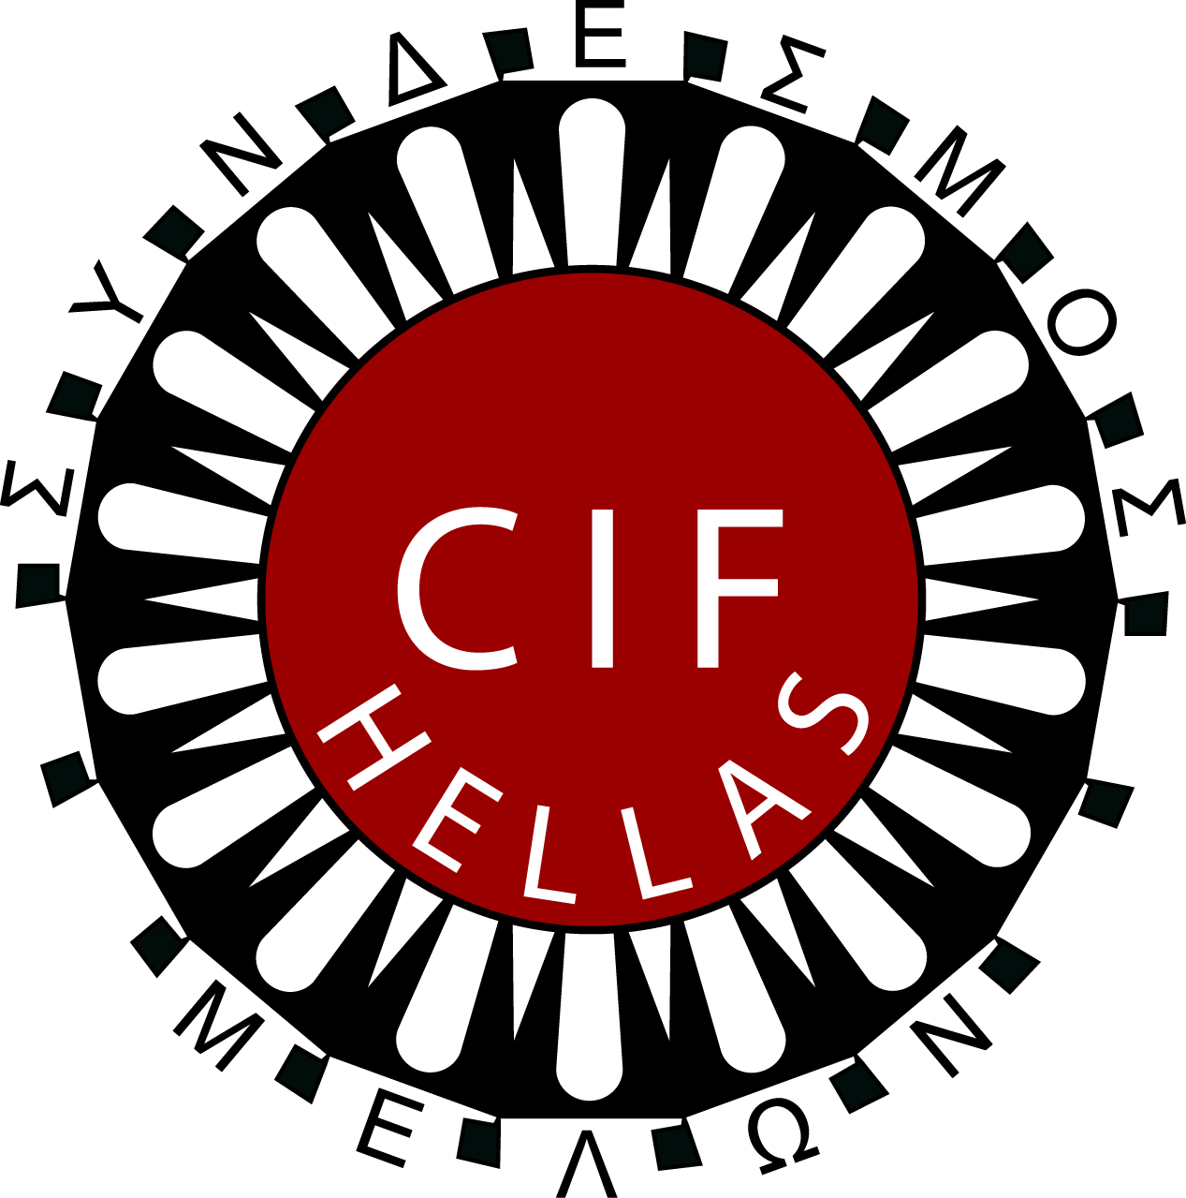**INTERNATIONAL PROFESSIONAL EXCHANGE PROGRAM 2025**

**Athens 24 May – 06 June 2025**

Professional, cultural and educational exchange program for social workers and Professionals working in the field of human services

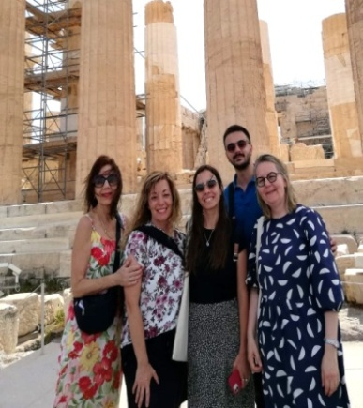 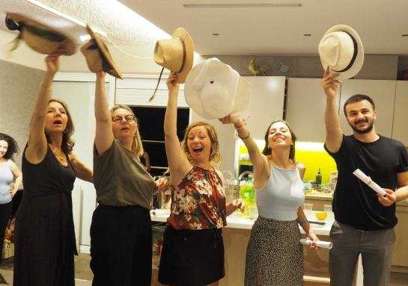

***The program includes:***

**-Orientation:**Seminar and lectures to familiarize participants with the socio/economic situation in Greece. Including also visits to places of cultural interest.

**-Agency visits:** Participants will visit social organizations and agencies.

**-*Individual placements*:** related to their own specialized field, to observe and experience professional social work in Greece.

**-Experience in a multicultural group:**  
Participants will exchange experiences about their work

**-Evaluation and Farewell event:** The last two days participants will share gained knowledge and experience and will receive their certificates.

***-Host Family Living:*** *Living with host families provides participants with a unique cultural experience and develops lasting cross-cultural friendships.*

**- *Language:*** *English*

***- Number of participants:*** *Five (****5****)The program will take place only if more than* ***three****(3) successful applicants are able to participate.*

**The Financial terms:400 euro** as a contribution to program costs.

The participants are responsible for their international travel and medical insurance. Internal transportation and half board expenses are covered by the program.

**Deadline for applications** is 30/01/2025 through the National Branch, Contact Person and for countries without NB or CP directly to CIF Hellas, [cifhellas@cifhellas.gr](mailto:cifhellas@cifhellas.gr)

More information: [www.cifhellas.gr](http://www.cifhellas.gr) and [www.cifinternational.com](http://www.cifinternational.com)